Interphase | 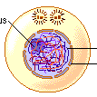
Prophase | 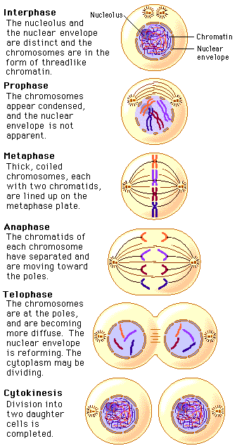
Metaphase
Anaphase
Telophase
Interphase

- The cell functions as normal
- The DNA is in the form of threadlike chromatin
- The DNA duplicates itself
- New nuclear membranes start to form around the chromosomes
- The cell pinches in the middle and splits into two
- The chromosomes start to unwind
- The DNA unwinds into threadlike chromatin
- The two new cells function normally
- The DNA condenses into visible chromosomes
- Each chromosome now has an identical copy attached at a centromere
- The nucleus membrane breaks down
- The spindle begins to form around the chromosomes
- The chromosomes line up in the centre of the cell
- A spindle fibre attaches to the centromere of each chromosome
- The chromosomes separate at the centromere
- The spindle fibres contract, pulling half of each chromosome to each end of the cell

